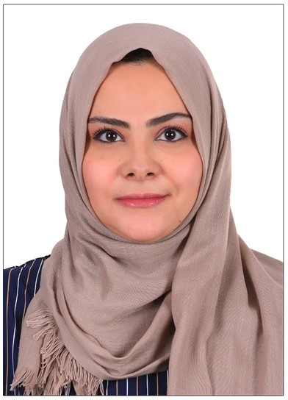 |  | Buthaina Munir Yousif Elhakim  Life Coach & Mental Health Specialist  Marketing and Management Specialist  Cairo, Egypt  Madinaty  About  Certified life coach and trainer with experience in issues such as relationships, parenting, and offering guidance. Possess great active listening and communication skills. Proficient in motivating and inspiring clients.  Additionally, I bring real life experience leading multi-disciplinary teams while delivering actionable solutions in the form of marketing reports, overall campaign effectiveness, customer analytics, segmentation, and insights.  Education:  - Jan. 2018: MBA (MASTERS OF BUSINESS ADMINISTRATION) - SUDAN OPEN UNIVERSITY  - Aug. 2015: LCCI (LONDON CHAMBER OF COMMERCE) - LEVEL 3 CERTIFICATE (with Merit)  - Oct. 2010: BACHELOR DEGREE INBUSINESS ADMINISTRATION (V.Good) - SUDAN OPEN UNIVERSITY  Experience:  - Training of Trainers TOT – (Oct. 2022 - Present)  - Certified Professional Coach - (Jan. 2022 - Present)  - Mental Health Specialist – (Aug. 2022 - Present)  - ASMER FOR SERVICES AND INVESTMENT CO. Marketing Manager – (Sept. 2018 – Dec. 2018)  - KEY2MARKET MANAGEMENT SOLUTIONS CO. Marketing Executive - (Aug. 2015 – Sept. 2018)  - Hatain International Charity organization for Orphans Development Assistant Manager - (Jul. 2011 – Aug. 2012)  Added Value:  - Proficient in Arabic and English  - Eligible for Level 6 of CIM professional degree (October 2019)  - ICDL (International Computer Driver License) certificate 2010  - Strategic planning and managing projects. Attended Strategic  - Planning Training course at Capacities International Organization (April 2011)

Buthaina Elhakim
CPC (certified professional coach)

CONTACT
PHONE:
+20 1113071720

INSTAGRAM:
@b_the_lifecoach

EMAIL:
Buthainaelhakim84@gmail.com

